**Loft Insulation Offer gives Suffolk residents 50% off eco-friendly insulation**

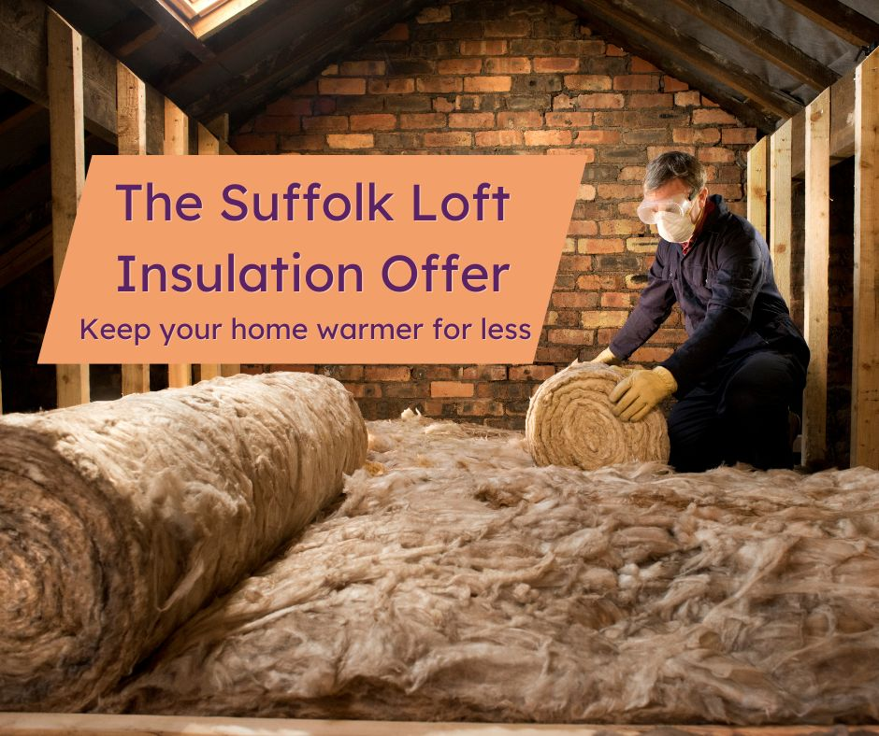

According to The Energy Saving Trust, an uninsulated home loses a quarter of its heat through its roof. For the second year in a row, help to afford eco-friendly loft insulation is now available for Suffolk residents.

The Suffolk Climate Change Partnership has teamed up with an insulation provider to help Suffolk residents make their homes warmer and save money on their energy bills.

Residents will receive a 50% discount off their purchase of 200mm or 370mm wide insulation rolls (up to £200) with free delivery, from High Loft, the UK's leading eco loft insulation brand.

The offer is open to anyone in Suffolk and will close once the allocated funding has been spent. Simply go to [www.bit.ly/suffolkloft](https://www.bit.ly/suffolkloft) and fill in the form to receive your personalised link to order, or call High Loft's insulation experts on 01706 248203 (Mon – Fri, 9am - 5pm).

Or, to find out more visit [www.greensuffolk.org/at-home/funding.](https://www.greensuffolk.org/at-home/funding)